Project Design Phase-II
Data Flow Diagram & User Stories

Date | 12 October 2026
Team ID | SWTID-2026-5604
Project Name | AI Blognest API
Maximum Marks | 4 Marks

Data Flow Diagrams:
A Data Flow Diagram (DFD) is a traditional visual representation of the information flows within a system. A neat and clear DFD can depict the right amount of the system requirement graphically. It shows how data enters and leaves the system, what changes the information, and where data is stored.
Example: DFD Level 0 (Industry Standard)
Example: (Simplified)
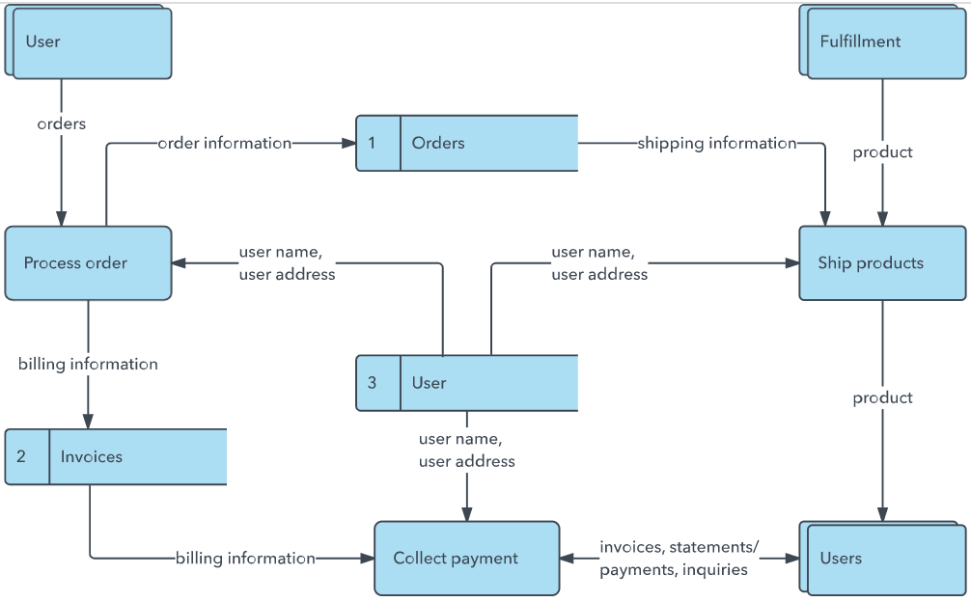


User Stories
Use the below template to list all the user stories for the product.
User Type | Functional Requirement (Epic) | User Story Number | User Story / Task | Acceptance criteria | Priority | Release
Sprint-1 | User Management | USN-1 | As a user, I can register and log in to manage my blog drafts. | 3 | High | Backend / Frontend
Sprint-1 | AI Blog Generation | USN-2 | As a user, I can generate a blog draft from a topic or prompt. | 5 | High | API / AI Integration
Sprint-2 | Summarization | USN-3 | As a user, I can generate a concise summary for a blog post. | 3 | Medium | AI Integration
Sprint-2 | Blog Editing | USN-4 | As a user, I can edit and save generated blog drafts. | 3 | High | Frontend / Backend
Sprint-1 | Authentication | USN-5 | As a user, I can securely log in and access my dashboard. | 2 | High | Backend
 | Dashboard
Customer (Web user)
Customer Care Executive
Administrator

